RGBA Color Model

📘 Definition
# Source: AI Source: Provided by: [Data Path: Persons Table -> ID Column: 1, Name_En Column: Motasem Essam] -> From: [ChatGPT] on [5/2/2026]
The RGBA color model is an extension of the RGB model that adds an extra component called Alpha (A), which controls transparency (opacity).
It is used in computers, web design, and graphics to create colors that can be solid or see-through.

🎨 What RGBA stands for
# Source: AI Source: Provided by: [Data Path: Persons Table -> ID Column: 1, Name_En Column: Motasem Essam] -> From: [ChatGPT] on [5/2/2026]
- R = Red
- G = Green
- B = Blue
- A = Alpha (opacity / transparency)

🧠 How it works
# Source: AI Source: Provided by: [Data Path: Persons Table -> ID Column: 1, Name_En Column: Motasem Essam] -> From: [ChatGPT] on [5/2/2026]
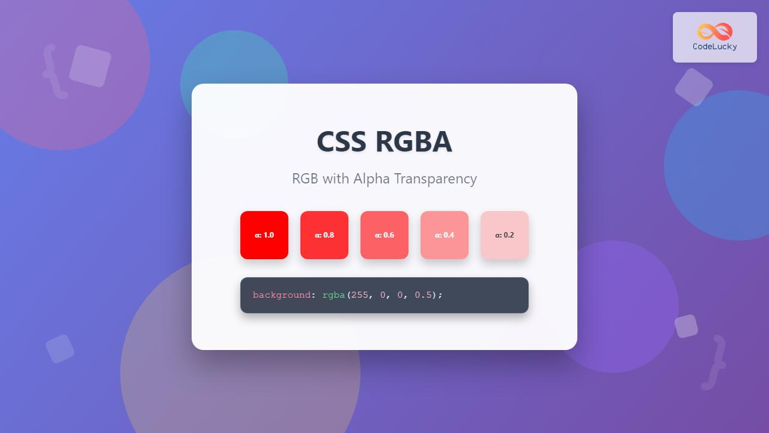
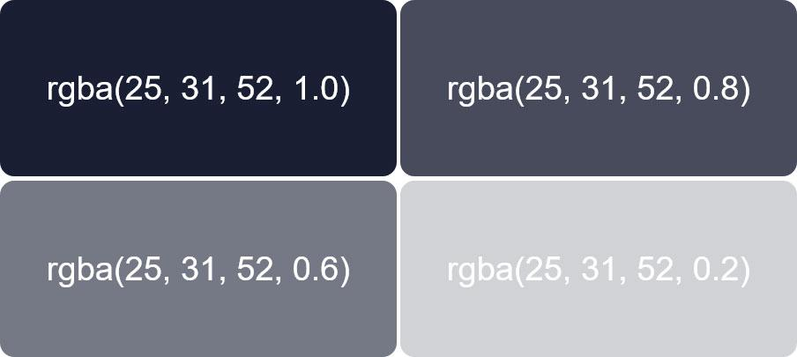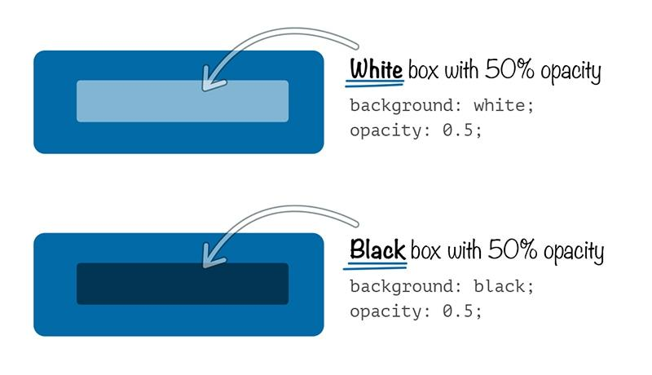
- RGB controls the color
- Alpha controls how visible or transparent it is
Alpha values usually range from:
- 0 = fully transparent (invisible)
- 1 = fully opaque (solid color)

🎯 Examples of RGBA values
# Source: AI Source: Provided by: [Data Path: Persons Table -> ID Column: 1, Name_En Column: Motasem Essam] -> From: [ChatGPT] on [5/2/2026]
- Solid Red → rgba(255, 0, 0, 1)
- 50% Transparent Red → rgba(255, 0, 0, 0.5)
- Fully Transparent Blue → rgba(0, 0, 255, 0)
- Green with 75% visibility → rgba(0, 255, 0, 0.75)

🖥️ Where RGBA is used
# Source: AI Source: Provided by: [Data Path: Persons Table -> ID Column: 1, Name_En Column: Motasem Essam] -> From: [ChatGPT] on [5/2/2026]
- Web design (CSS colors)
- Graphic design tools
- Game development
- UI/UX design (buttons, overlays, menus)

🚀 In short:
# Source: AI Source: Provided by: [Data Path: Persons Table -> ID Column: 1, Name_En Column: Motasem Essam] -> From: [ChatGPT] on [5/2/2026]
RGBA color model = RGB colors + transparency control (Alpha).

